LO1
Structure and function of an operating system

1.1The main functional elements of a computer operating system

What is an operating system?
System software designed to enable you to run a computer without having to know exactly what’s going on inside. System software controls the actual operation of the computer system. You can enter instructions to the computer by typing at the keyboard or clicking on a mouse and the system software will convert these instructions into the thousands of low-level operations needed for the computer to carry them out appropriately. The operating system is part of the system software.

The purpose of an operating system is to provide the user with a means of operating the computer. As a long established category of software, there is a wide range of different operating systems, each with the task of providing a user with an element of control.

The operating system can be viewed as providing a layer of software between the user, applications and the underlying hardware of the machine. This operates both to the benefit of the user who is insulated from needing to know the detail of how the hardware works and to the benefit of the system which is protected from inappropriate actions by the user.

Each operating system provides a different amount of control over a machine, with some, such as the operating system on 1980s Home Computers providing a fairly basic level of service, while others, such as Microsoft Windows XP or recent Linux distributions provide an enormous range of facilities.

Opinions vary as to the best way of writing the software that comprises an operating system, with some preferring to write much of the operating system as one enormous program, while others suggest that an operating system should be divided into several different programs that cooperate to provide services. In either approach there will usually be a categorisation of functions into different areas.

One common approach is that an operating system can be described as having five areas of functionality. These five areas are:
- user interface;
- file management;
- input and output;
- memory management;
- kernel.

An operating system is meant to provide these features, but it is not only these alone by which a system is judged. Other criteria include:
- cost;
- ease of installation;
- ease of management (how easy it is to add new devices, how much time you have to spend working at the operating system rather than on the applications);
- reliability (how often it hangs);
- performance (how fast it works, how much throughput it can handle);
- range of platforms (how many different kinds of computer it can run on);
- range of software (what applications are available for it);
- customisation (how easily and how much the system can be adapted to particular uses and users).

Starting up
The most essential and frequently used instructions of the operating system are held in main memory. This part of the operating system is known as the supervisor, executive or kernel . The remaining part of the operating system can be loaded into memory whenever it is needed.
When a computer is powered up it carries out a series of tasks to check that the basic hardware is operating correctly. It then tries to load the operating system program into the main memory. Checking hardware, locating and loading the operating system is carried out by a small program called a boot program that is held in ROM. Even if the operating system is disk based, a small part of it, the boot program still needs to be held in ROM.

The term booting comes from the expression "to pull yourself up by your own bootstraps". This means that the operating system builds its capability using what it already has, the ROM boot program, to load itself from disk into RAM.
Once the operating system is loaded into main memory, it runs until the computer is switched off.
While this process is not identical to that used on large computers, the functions performed are similar.
ROM based operating systems
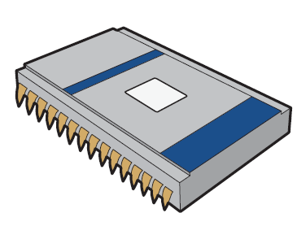

In ROM based operating systems, the operating system is held on a ROM chip. This has the advantages of releasing main memory for applications and preventing the operating system from being corrupted. It also has the advantage of taking very little time to load and be up and running.

Changes to the operating system require an alteration to the ROM program and subsequent chip replacement.
This is a procedure that most users would rather not undertake themselves, preferring to pay professionals to do it.

Disk based operating systems
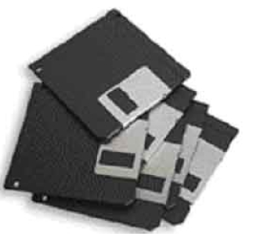
With a disk based operating system the system software is held on backing storage and loaded into main memory when the machine is switched on.

Some computers have the operating system and utility software pre-installed on the hard disk. With others, the user must install and configure the software.
In older computer models, systems software was distributed on floppy disks which also served as a backup. These days, desktop operating systems are so large that they are distributed on CD-ROM, or upgrades can be downloaded directly from manufacturer’s web sites.

User interfaces
Abbreviated UI, the junction between a user and a computer program. An interface is a set of commands or menus through which a user communicates with a program. A command-driven interface is one in which you enter commands. A menu-driven interface is one in which you select command choices from various menus displayed on the screen.
The user interface is one of the most important parts of any program because it determines how easily you can make the program do what you want. A powerful program with a poorly designed user interface has little value. Graphical user interfaces (GUIs) that use windows, icons, and pop-up menus have become standard on personal computers.
There a many different types of user interfaces currently in use. Each different type of interface can be characterized by the style of interaction it supports. Style of interaction refers or manner in which you interact. The most common styles include:
- form filling;
- menu driven;
- command and graphical user interfaces;
- natural language.

Styles are chosen by interface designers to support particular tasks. Many systems have a mixture of different styles of interaction to support different tasks and subtasks. If you are using a Graphical User Interface such as Windows you will also find a form filling style of interaction if you are asked to register the software. It is important to note that the different styles of interaction exert different levels of control over the user. Command line interfaces exert little control, i.e. the user can type what s/he wants. On the other hand a form filling interface restricts the kind of interaction that the user can peform.

Form filling
Form Filling menus are commonly seen in software such as database systems or as subsystems of other styles of interaction such as GUIs. The forms are used to control the type of information the user can input and many form filling interfaces can be quite smart in detecting that the wrong type of data has been input. This style of interaction is very common for registration or purchase where detailed information in various categories is needed.

Menu driven
Menu based interfaces provide the users with a set of options from which they choose.
The way that menus are presented on screen varies but at the heart of menu based systems lies the knowledge that users are much better at recognising things as compared to remembering. The menus provides clues and this form of interaction is very good for non-computer oriented users and shortens the amount of time required to learn how to use an interface.

Command and graphical user interfaces
The user interface is provided to allow the user to issue instructions to the operating system and receive the results of the instructions that have been issued in the past.
Current systems provide two different types of user interface:
- the command line interface (CLI);
- the graphical user interface (GUI)

The central module of an operating system. It is the part of the operating system that loads first, and it remains in main memory. Because it stays in memory, it is important for the kernel to be as small as possible while still providing all the essential services required by other parts of the operating system and applications. Typically, the kernel is responsible for memory management, process and task management, and disk management.

